Shaker for Microplates—MS100
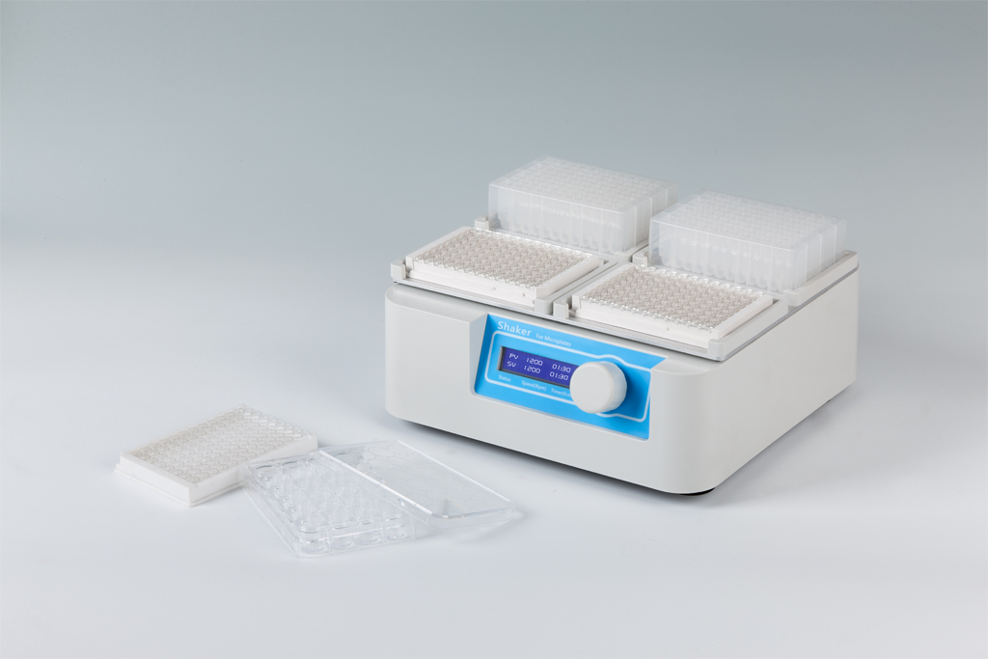
Description:
MS100 Shaker for Microplates is a type of high speed shaker, which is with brushless DC motor and microprocessor controlled technique, specially for elisa plates (96/384 wells), tissue culture plates (24/48/96 wells).

Features:
- LCD display system status and parameters.
- Stable and reliable shaking.
- Easy to operate with one touch knob.
- Automatic fault detection and buzzer alarm function.

Parameters:
Type  Parameter | MS100
Time range | 1min ~ 99h59min
Speed range | 200～1500rpm
Mixing orbit | 3mm
Speed step value | 10rpm
Sample capacity | 4plates
Power | 45W
Voltage | AC100V~240V 50/60Hz
Dimension(mm) | 280×270×110
Weight(kg) | 4.0

